







UID /help/

ReadySetResource.com

Contents

11.1 - Home 3

11.2 - User Manual 4

11.3 - Technical Manual 5

11.4 - FAQ 6

11.5 - Question Query 7

11.6 - Editable Question 8

11.7 - Report Question 9

11.8 - UID /help/ Work Log 10

# 11.1 - Home

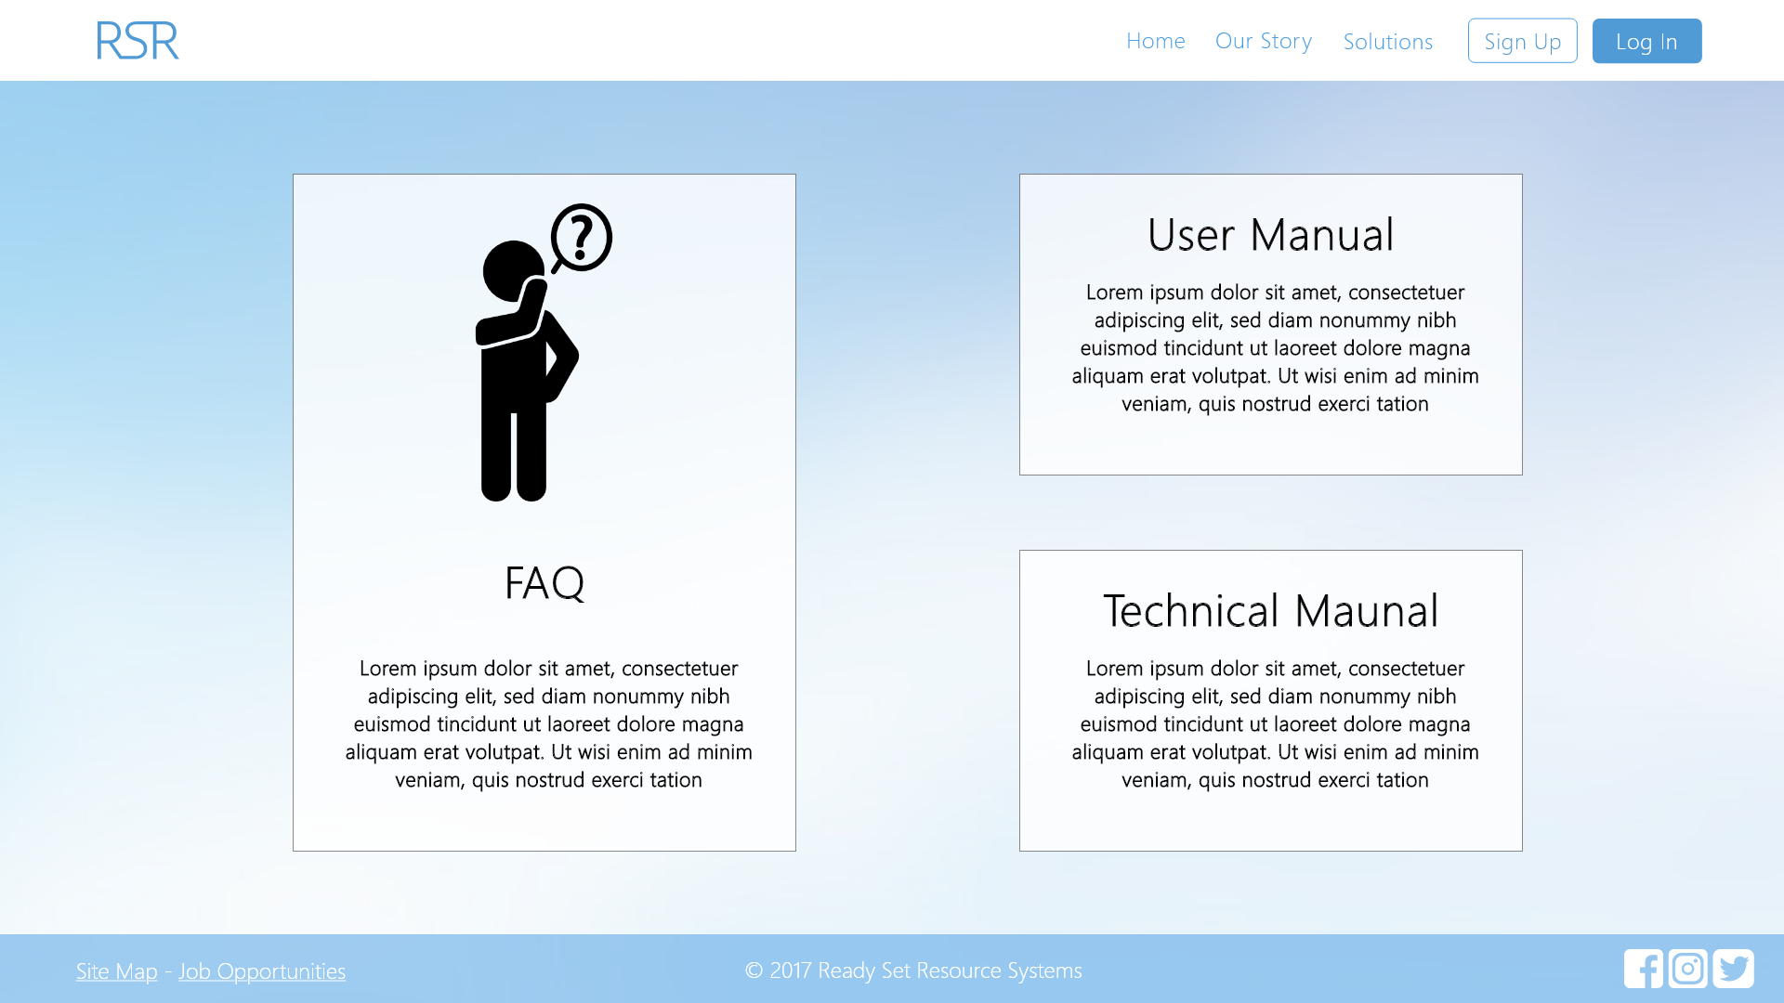

Input Permissible: None

Error Messages: None

# 11.2 - User Manual

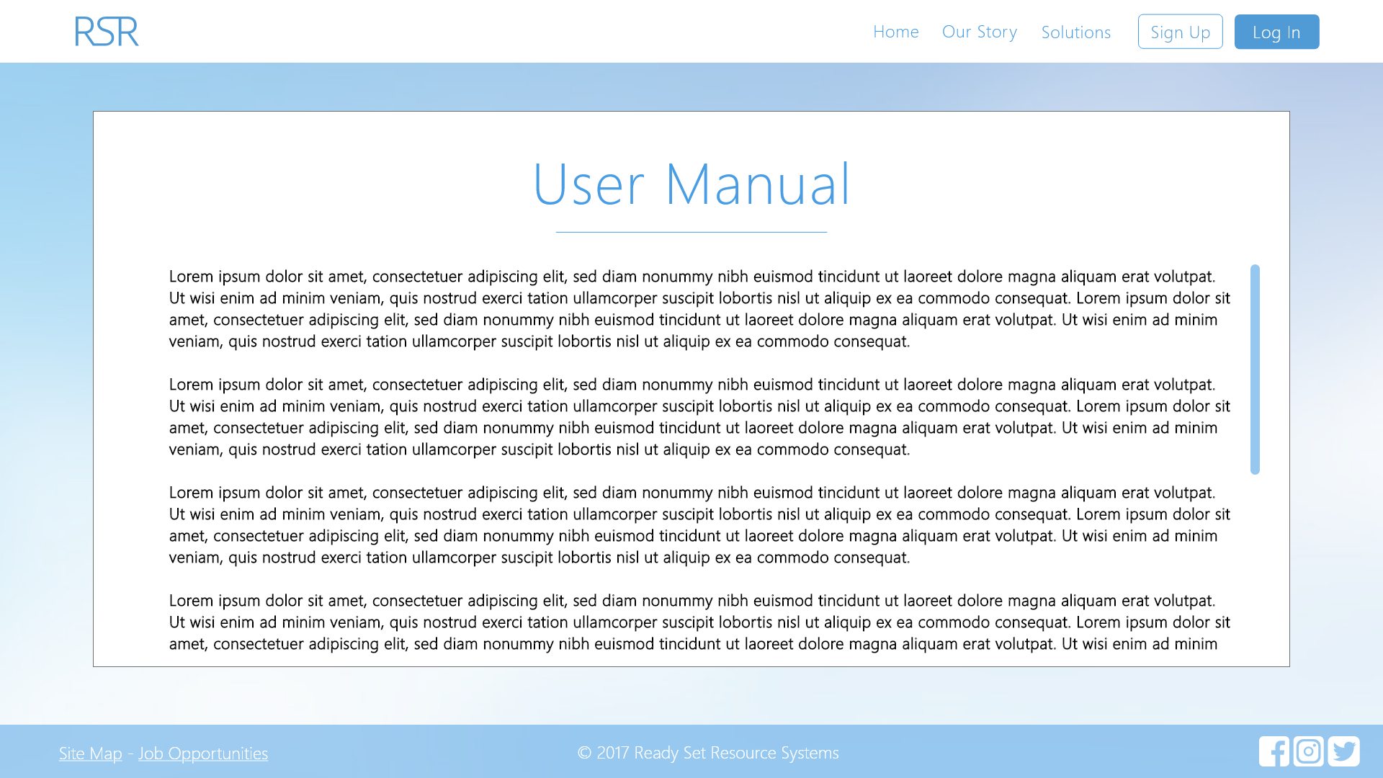

Input Permissible: None

Error Messages: None

# 11.3 - Technical Manual

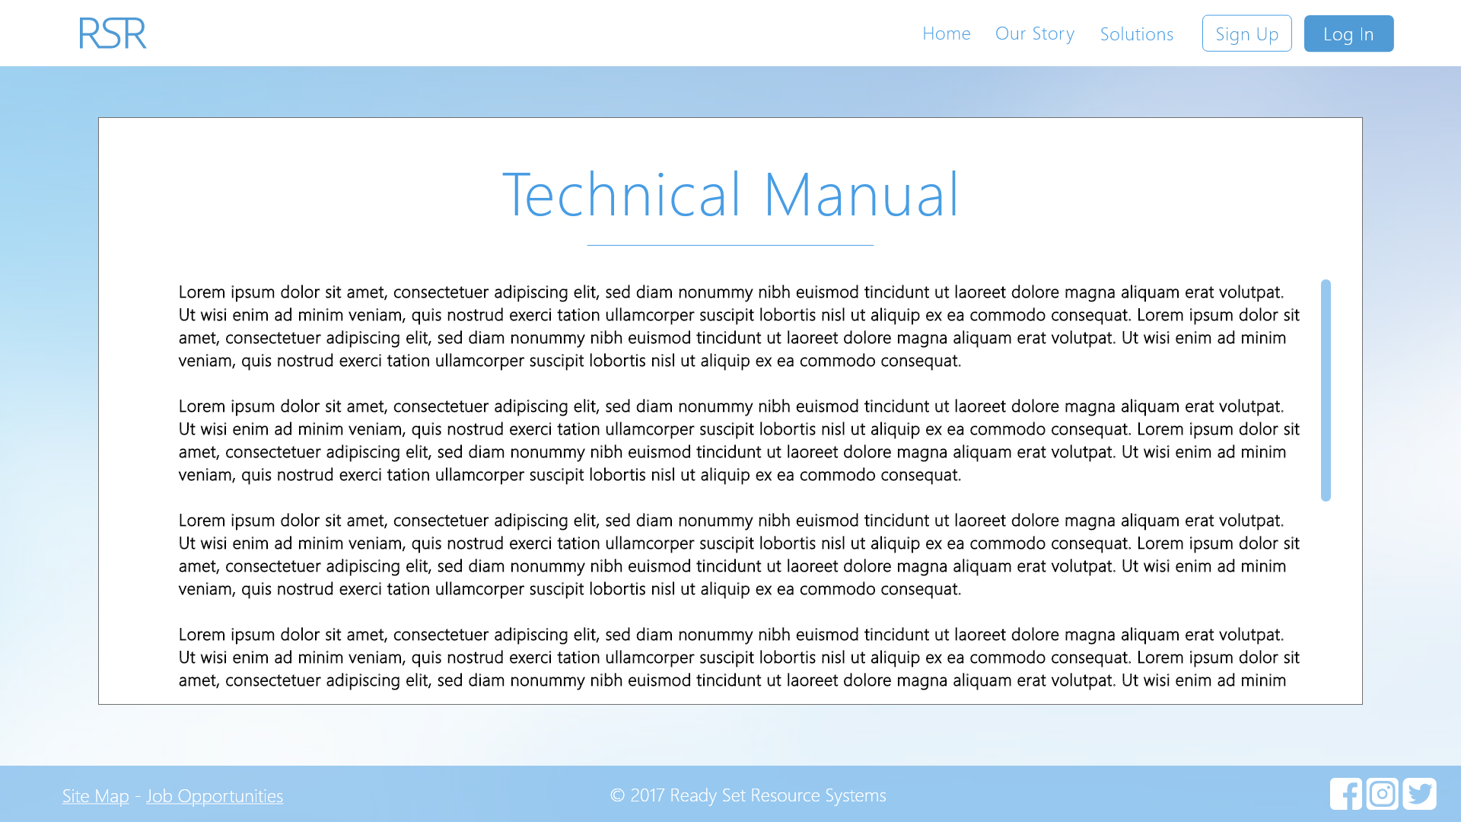

Input Permissible: None

Error Messages: None

# 11.4 - FAQ

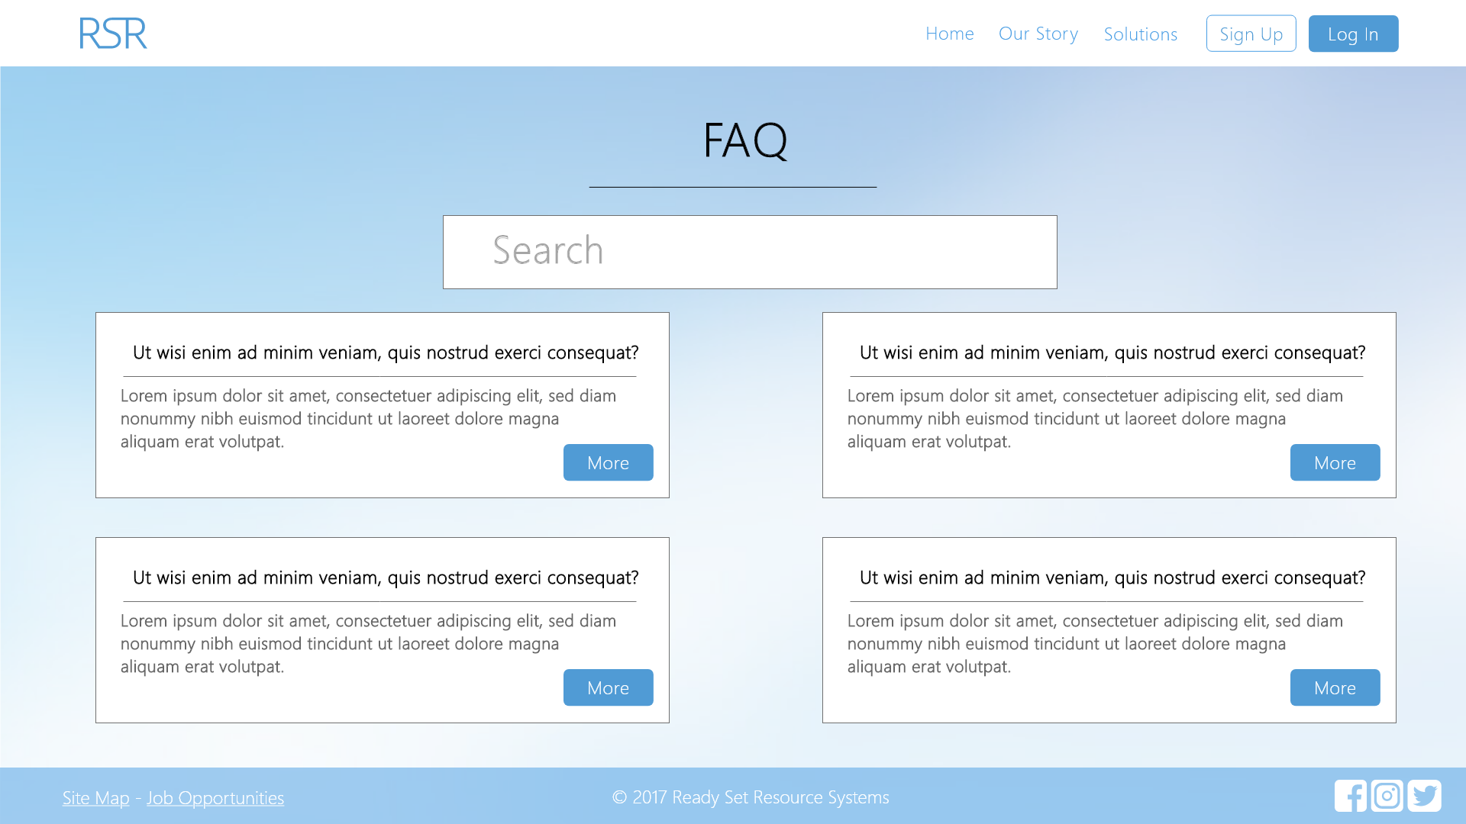

Input Permissible: - Search String

Error Messages: None

# 11.5 - Question Query

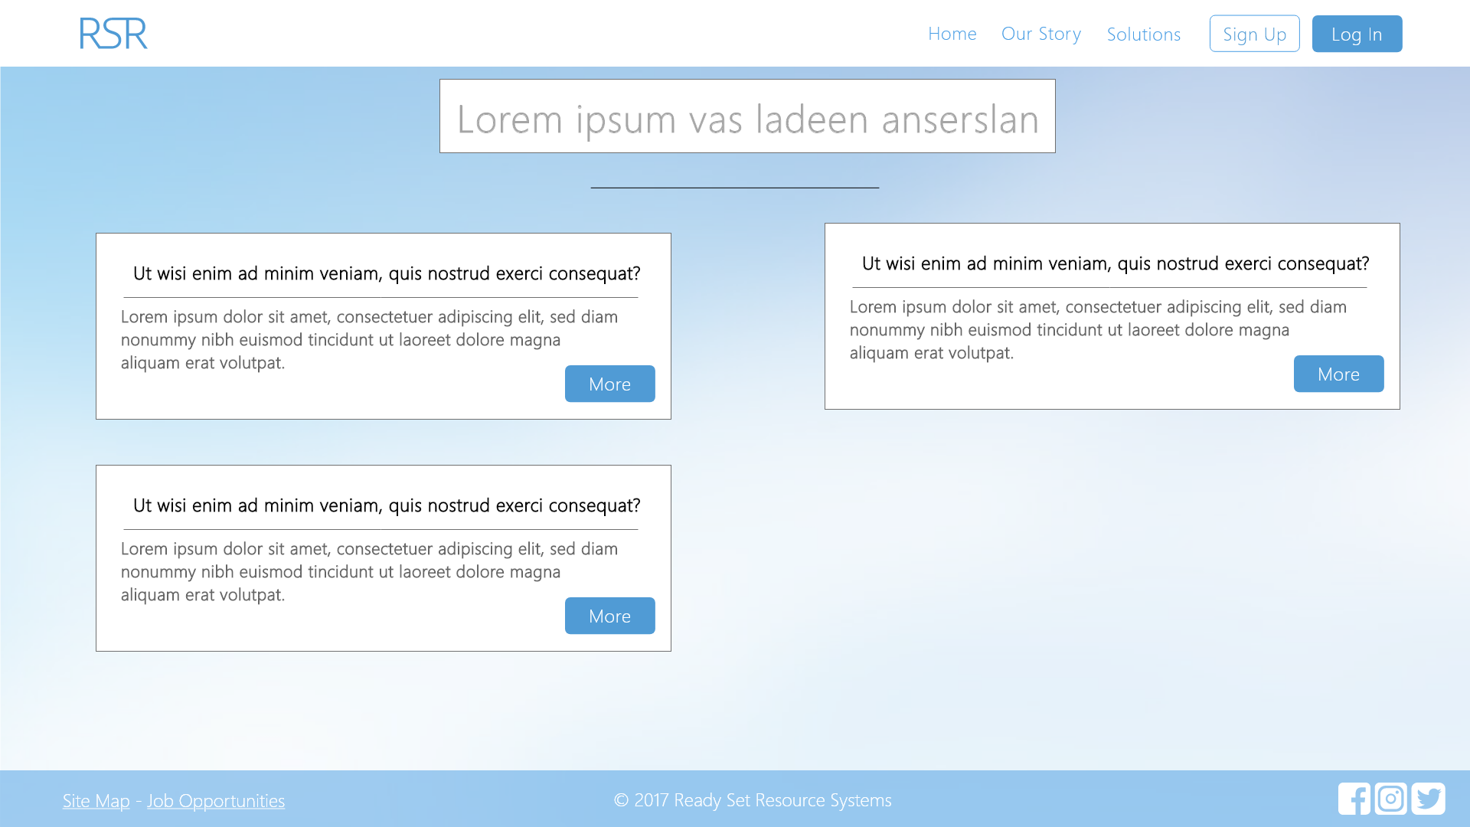

Input Permissible: - Search String

Error Messages: None

# 11.6 - Editable Question

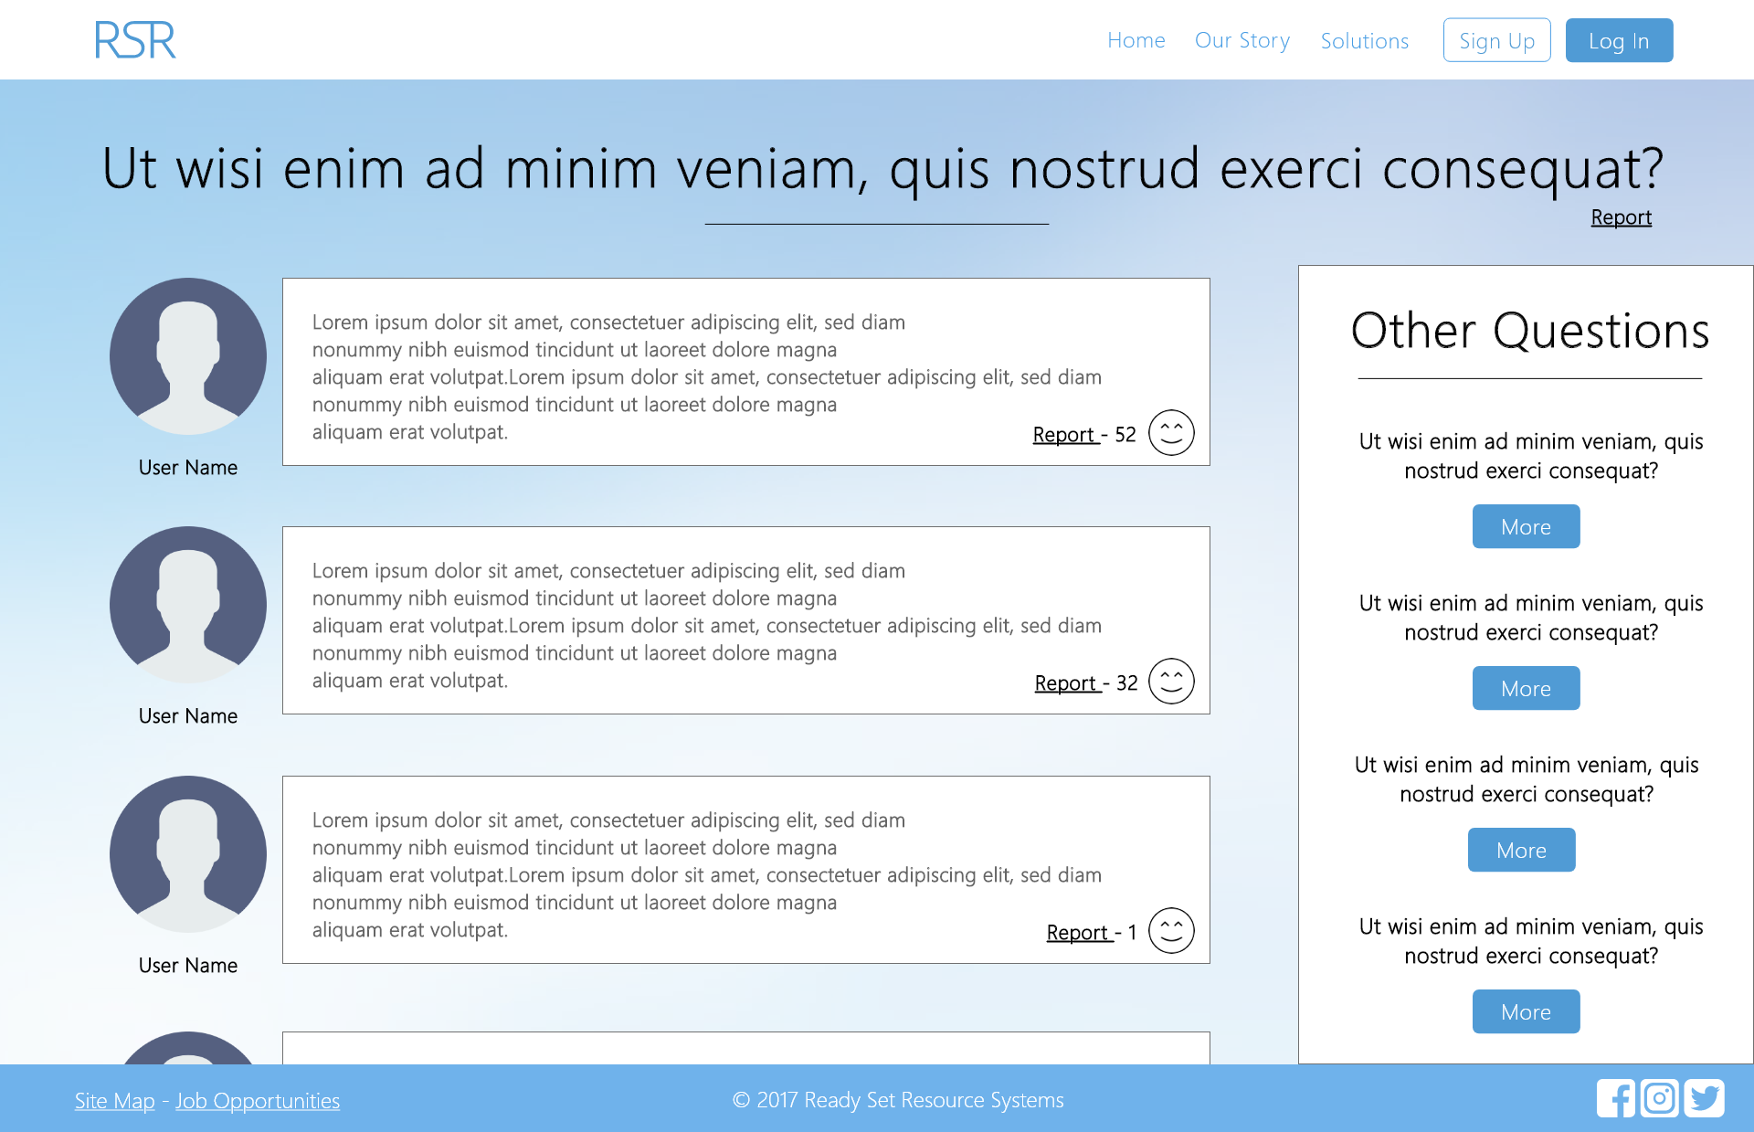

Input Permissible: None

Error Messages: None

# 11.7 - Report Question

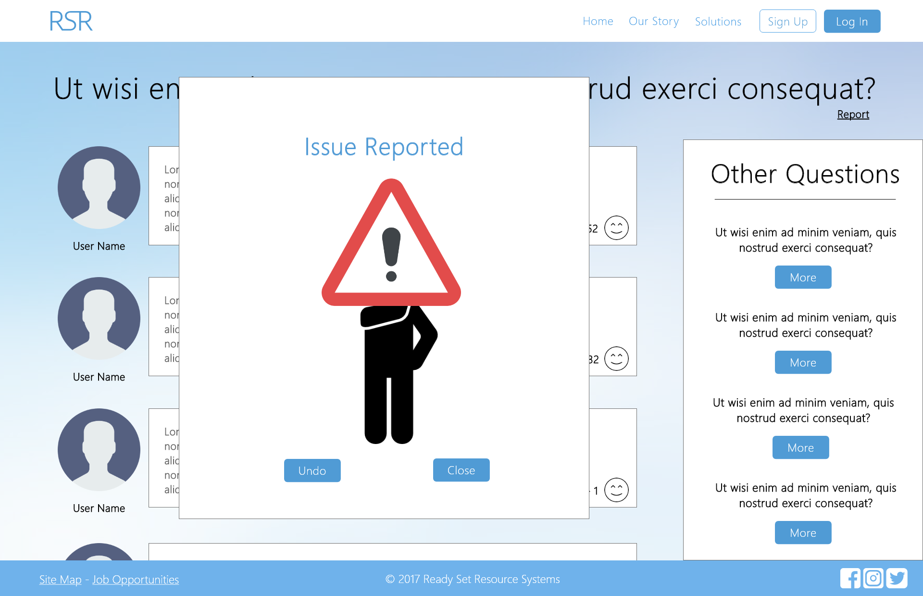

Input Permissible: None

Error Messages: None

# 11.8 - UID /help/ Work Log

| Entry | Description | Person | Date | Mins Spent |
| --- | --- | --- | --- | --- |
| 1 | Formatted the document | Aidan Marshall | 19/3/18 | 7 |
| 2 | Designed the website | Aidan Marshall | 7/10/17 | 209 |
| 3 | Added screenshots and page details | Aidan Marshall | 7/10/17 | 23 |
| 239 | | | | |